EXP 10: **RECRUITMENT SYSTEM**

**AIM : To draw uml diagrams for recruitment system using umbrello.**

**PACKAGE DIAGRAM :**

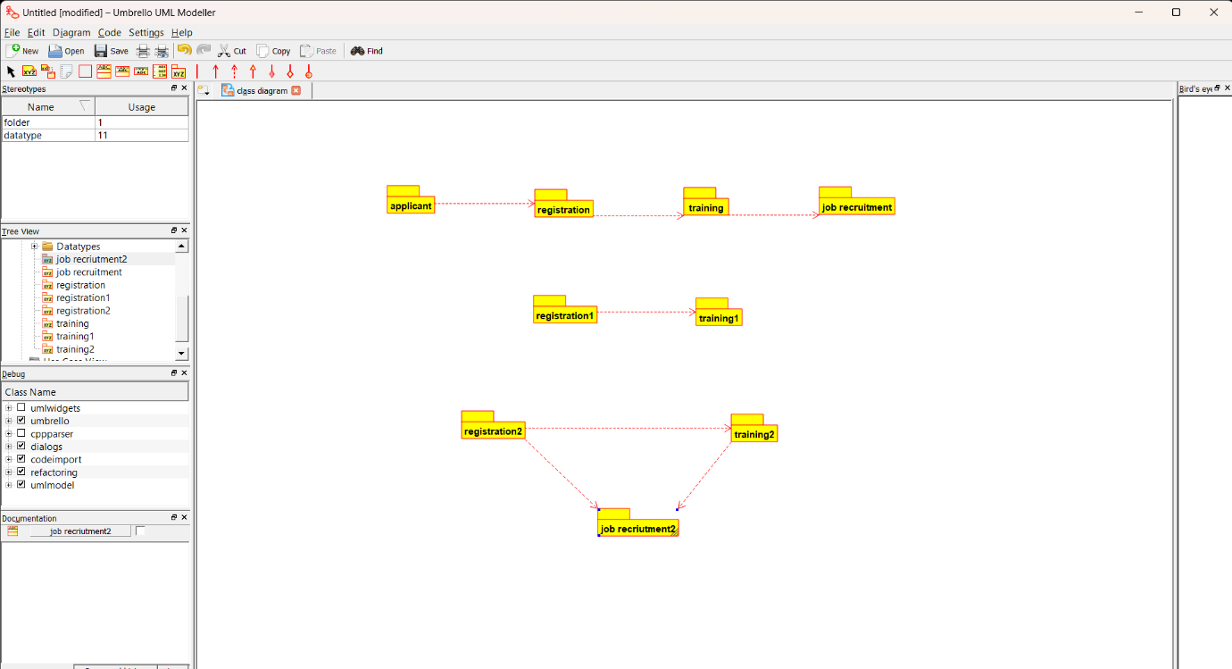

**DEPLOYMENT DIAGRAM :**

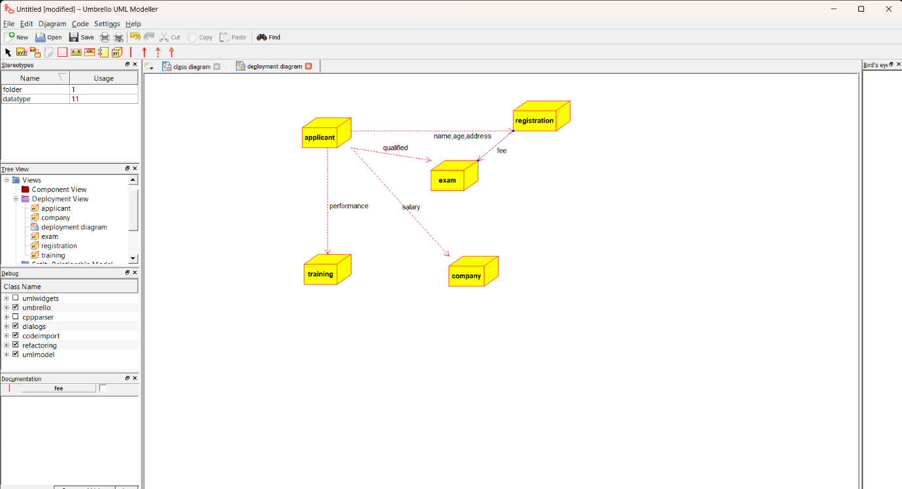

**COMPONENT DIAGRAM:**

